1. **CREATE THE ARFF FILE FOR THE DIABETES DATABASE AND PERFORM THE RULE BASED CLASSIFICATION.**

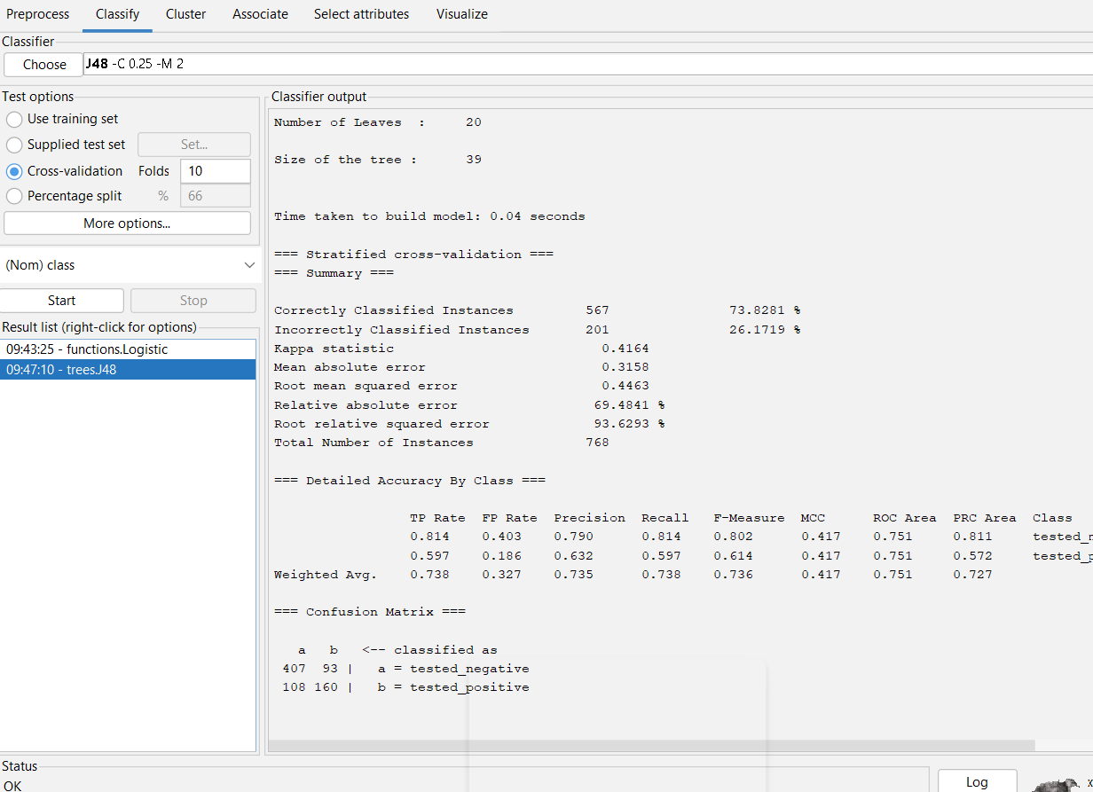

**Output info of diabetes by rule based classification.**

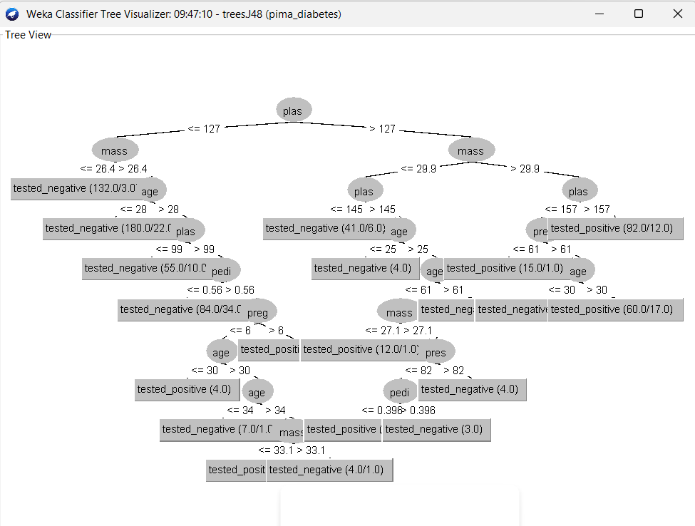

**Tree view of diabetes on rule based classification.**

*. R PROGRAM FOR SORTING VECTOR

